

**How to win Robot Wars**

**By Edgar Burns**

Contents

My Rationale 4

Timetable 6

Revised timetable 7

Revised Timetable 8

My core ideas 8

Robot wars spider diagram 9

Third spider 10

Apollo 11

Carbide 12

Research on Dave Moulds and Sam Smith 14

Mechanical Prototype 15

Shell Prototype 18

Control Prototype 20

WIFI command diagram 21

Programming the Pi 22

Program 1 22

Program 2 23

Program 3 24

Program 4 26

Program 5 28

My survey questions 31

What is the most exciting robot to watch in robot wars? 31

What can sustain the most damage? 31

What can deal the most damage? 31

What is the most agile robot? 31

What robot is easiest to drive? 31

What robot is hardest to deal damage to? 31

Survey responses 32

Interview 33

What is the most exciting thing about flippers to watch in robot wars? 33

Why can flippers sustain so much damage? 33

Why can spinners deal a lot damage? 33

Why are flippers the most agile robot? 33

Why are flippers easiest to drive? 33

Why are spinners hardest to deal damage to? 33

Methodology table 34

Bibliography 35

Evaluation 38

My HPQ story 38

How did I manage my time? 38

How thorough is my research? 39

What skills have I developed through doing the project? 39

Are my final outcomes what I originally intended or have the changed? 40

What difficulties did I face and how did I overcome them? 40

How could my project be built on? 41

What would I do differently if I were doing the project again? 41

Conclusion 41

My SWAT analysis 42

How to win Robot Wars. 43

Primary research 43

Secondary research 44

How to win robot wars? 44

Weapons 45

Batteries 47

Conclusion 48



My Rationale

**My first thought was ‘how games are promoting peace by introducing an extra-terrestrial race so humans have a common enemy’. But, when I started to research the idea I found that there is too little information on this topic which made it very challenging to progress.**

**These reasons led me to the idea of ‘How to win robot wars’. I tried to develop it further without making it too narrow and be stuck in the same position as my first idea! I came to the conclusion that my title would be ‘How to win robot wars (heavy weight category)’**

**I chose my topic for many reasons, a few of the main ones are:**

* **My dad and I have been planning to build a robot for some time.**
* **I am enthusiastic about robots and I really enjoy watching robot wars.**
* **There are a lot of engineers in my family so it would be easy to access professional opinions.**

**I am considering taking engineering as a career path so this seemed a good choice for now and the future as I am passionate now and it will be very relevant in the future as well. However, even if I do not follow a career path in engineering it will still be very useful as I could use it to show organisation, how I can stick to deadlines and also that I am capable of acquiring new skills This subject is very personal to me because I feel that my entire family has an interest in this subject and I will feel equal if I can do this to a good standard.**

**The format of my project is an artefact. I am going to create a robot as my final piece that will hopefully be weaponised and entered into robot wars. I chose an artefact because it will be a clear marker of how well I have done in my project, it will also make me stand out from the majority of projects because only me and 2 other people are doing artefacts out of a class of 15. I also chose to do an artefact because it is a way to show off my research and bring it all together so that I have a fitting conclusion.**

**There are a few problems I can see in my project. Some of these I have encountered however others will be later. One of these is that a heavyweight robot is complicated to build so I might have to use a small robot as my artefact to show the theory and the prosses as well.**

**In conclusion I think that my title is relevant and not too narrow but also interesting. I am passionate and very excited to see how the result looks and most importantly how well it works. I am also excited about the new experience as I have never built a robot before. The HPQ will be important as it will be a very good thing to put into my CV and also be a very enjoyable experience.**



## Timetable



## Revised timetable

## Revised Timetable

## My core ideas

Human like robots

Nintendo

Mobile phone

Xbox

Build robot/prototype

How pneumatics work

Computer science

Computer games

Robots

psychologically

Extra terrestrial

How do games encourage peace?

Extra terrestrial

How do games encourage peace?

I chose these three topics because I enjoy and am passionate about computers and engineering. I chose computer games specifically because I thought it would be fun to build a game, computer science because I like to know how things work like graphics and finally I chose robots because they are fascinating and I have always wanted to build one and possibly enter it into robot wars. I also chose robots because they are a glimpse of the future and what is to come.

How graphics work

History of graphics

graphics

Pc

PlayStation

Wheels

AR

Puzzle

Adventure

Action

Genre of game

Console for game

Create a game

First robots

motors

Walker/ shuffler

Guns

Spinners

Flippers

History of robot wars

History of pneumatics

Drive systems

Weapons

History of robots

Pneumatics

Robot wars

My HPQ

## Robot wars spider diagram

Spinner

Is it streamlined?

Who was the first flail?

Who was the first spinner?

Who was the first flipper?

Who is the most successful?

Who made robot wars?

Who was the first to win?

Will it be fast?

Will it be human like?

Will it be heavy?

Compressed CO2

Hydraulics

Pneumatic

The designs of it

How the weapons work

Previous winners

First robots

Flipper

Spinner

Axe/hammer

Shuffler

Walker

Flail

Wheels

Motor

Weapon types

Drive systems

History of robot wars

Build a robot

Robot wars

## Third spider

## Apollo

Location North Wales/ Chester

Weapon Flipper

Weight 110kg

Defence laser cut hardened steel armour

Top speed 20 mph

Drive system Ampflow A28-499-F48

Power Electric & pneumatic

Battery LiPo Batteries 48v

Biggest weakness Limited supply of carbon dioxide and exposed wheels at the back of the robot. (wars, 2018)

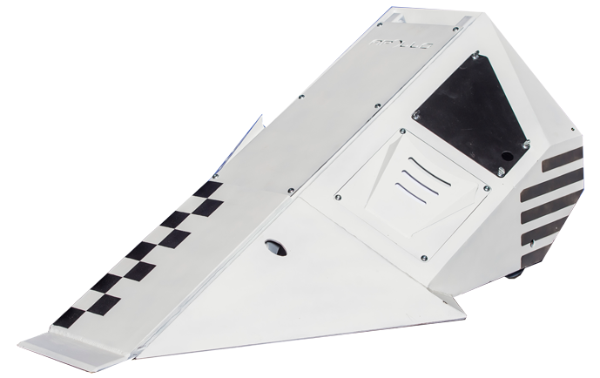

Figure 1: Apollo

## Carbide

Location Derby

Weapon Spinning Blade

Weight 110 kg

Top Speed 12 mph Drive System 2x 1.5 horse-power electric motors Power Electric Battery Lithium-Polymer, 58.8 volts.

Biggest Weakness Carbide had never been tested in battle before entering robot wars as the team have considered it too dangerous.

Spinner speed 2300RPM

Spinner power 20 horsepower

Spinner dimensions 85cm

Spinner weight 25kg

Tip speed of spinner 250mph

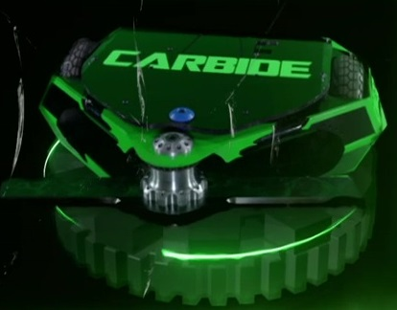Armour top panel of bullet proof glass, 5mm military grade steel, 8mm of aerospace grade aluminium and shock mounted top panel made of soft plastic. (wars, 2018)

Figure 2: Carbide series 9 robot wars winner

## Research on Dave Moulds and Sam Smith

Carbide is a heavyweight robot that competed in Series 8,9 and 10 of robot wars. In series 8 it finished runner up in series nine it won the competition and in series 10 it lost in the grand final against eruption. Carbide was the only robot since series 3 (Chaos 2) to have won the grand final by knockout. Carbide is an invertible bar spinner (Fadom, 2018).

Figure 3: Season 9 winner

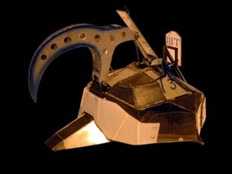Carbide’s makers Dave Moulds and Sam Smith had had great success with Tiberius 1,2 and 3. Tiberius’ weapon was a hydraulic claw that was meant to pierce the top of robots with its 1.5 tons of pressure. The engines were also strong enough to pull a Volkswagen Estate with its handbrakes on (Fandom, 2018).

Figure 4: Tiberius made by the same people as carbide

## Mechanical Prototype

First, I took apart our old printer for the micro switches and motors. I then started to build a base structure of this robot.

Figure 5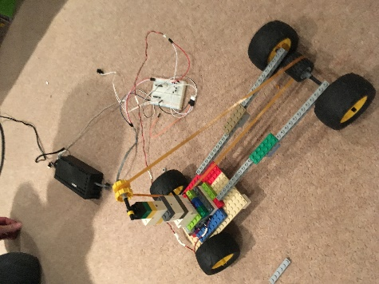 Shows my original model attached to the 20v DC power supply. I built this tower on the top to try to get the drive band taut so that the motor would be able to power it. However, the motor didn’t have enough of the drive belt around it hence it didn’t have enough grip. Because of this I was going to have to redesign it and find a way to tighten the drive belt. I have also attached a microswitch to the breadboard so I can start and stop the engine at the push of a button.

Figure 5: First prototype I built

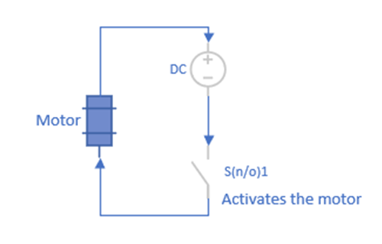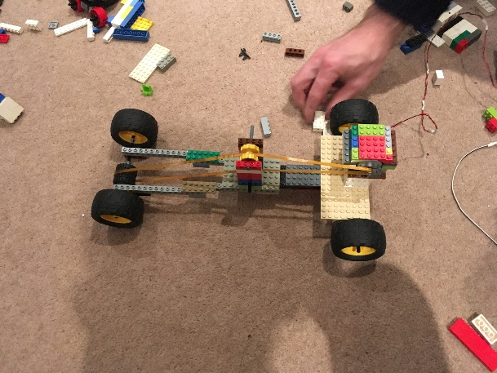

Figure 6: This is the circuit that the prototype is using

Figure 7: Second prototype I built

Now it is tightened and raps around a lot of the motor for grip. As you can see I have 2 yellow wheels in the middle that both push the belt up but spin with the belt as not to rub. The motor as you can see is still set in the same place at the back of the robot.

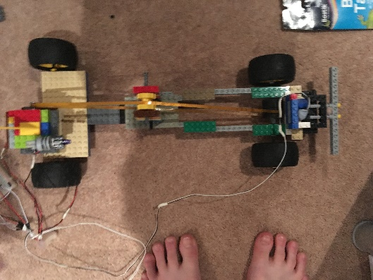

Figure 8: This is the third prototype I built and the last Lego one.

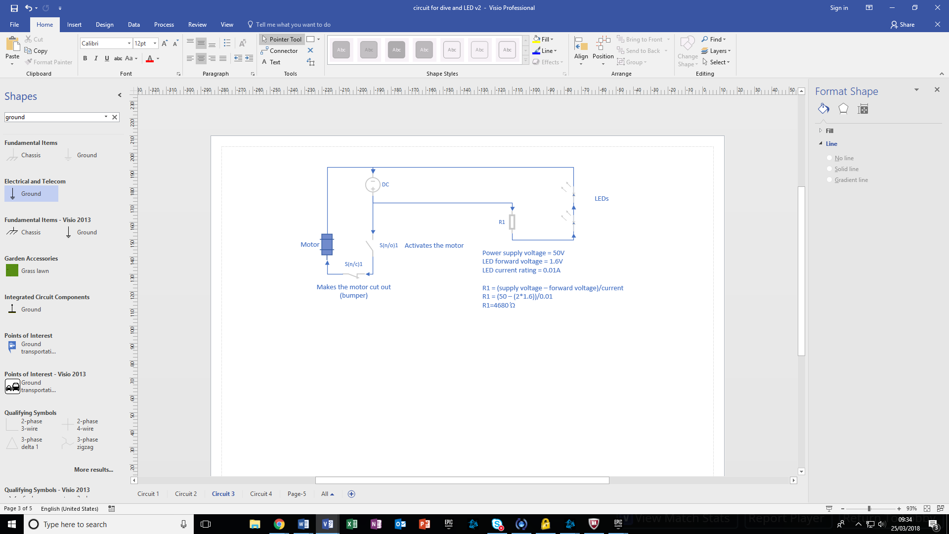I have now attached a bumper to the front of the robot that if hit will kill the engine so that it doesn’t damage the robot itself. I have done this by blue taking a micro switch to some Lego and attaching the bumper to an axle so if it gets hit the axle moves backwards and pushes the lever.

Figure 9: This is the circuit it is running on now

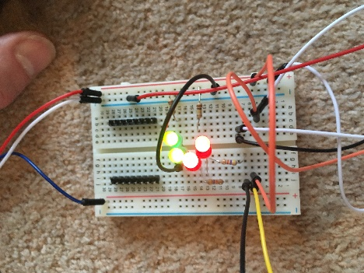Here I have put some LEDs into the breadboard preparing to mount them on the robot so the green goes on the front and the red at the back.

Figure 10: Here are LEDS that I might put on the robot

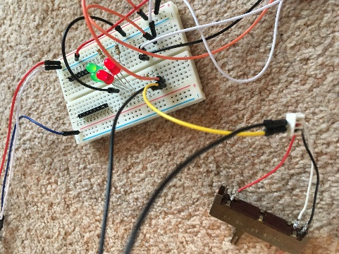

Here I have soldered an adjustable resistor to the LEDs so I can adjust how light they are.

Figure 11: In the bottom right is the resistor

## Shell Prototype

Figure 12: initial paper model

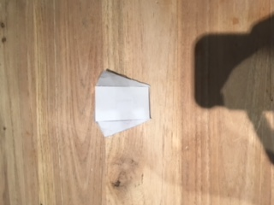

I made this prototype out of paper so that I could easily shape it and test that all the angles would work. My paper models allowed me to test out my designs and I figured out that the back couldn’t be straight otherwise it could get stuck on its back costing you the battle. Not only that but by doing this I am making it very easy for me to edit the design and change it throughout my phases of design.

Figure 13: initial paper model birds eye

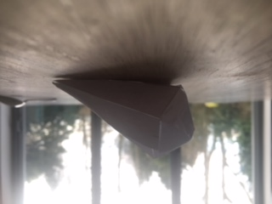

Figure 14: The back is less prone because its angled

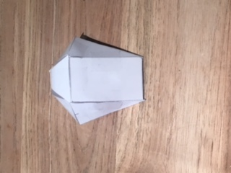

Figure 15: Second paper model Birdseye

## Control Prototype

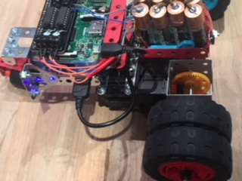

This is my final prototype as you can see on the front of it has one wheel that can turn I did this because on previous models it was turning very slowly and I tried it with one wheel and it turned a lot faster. Not only that but I built a case to hold the battery pack and the second battery and pi as you can see in figure 17. Not only that but I added a second wheel onto the axis to get more purchase on the floor to gain more control.

Figure 16: Final model

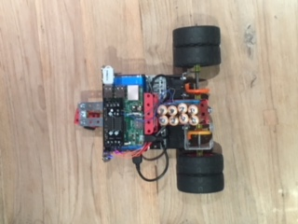

Figure 17: Final model Birdseye

## WIFI command diagram

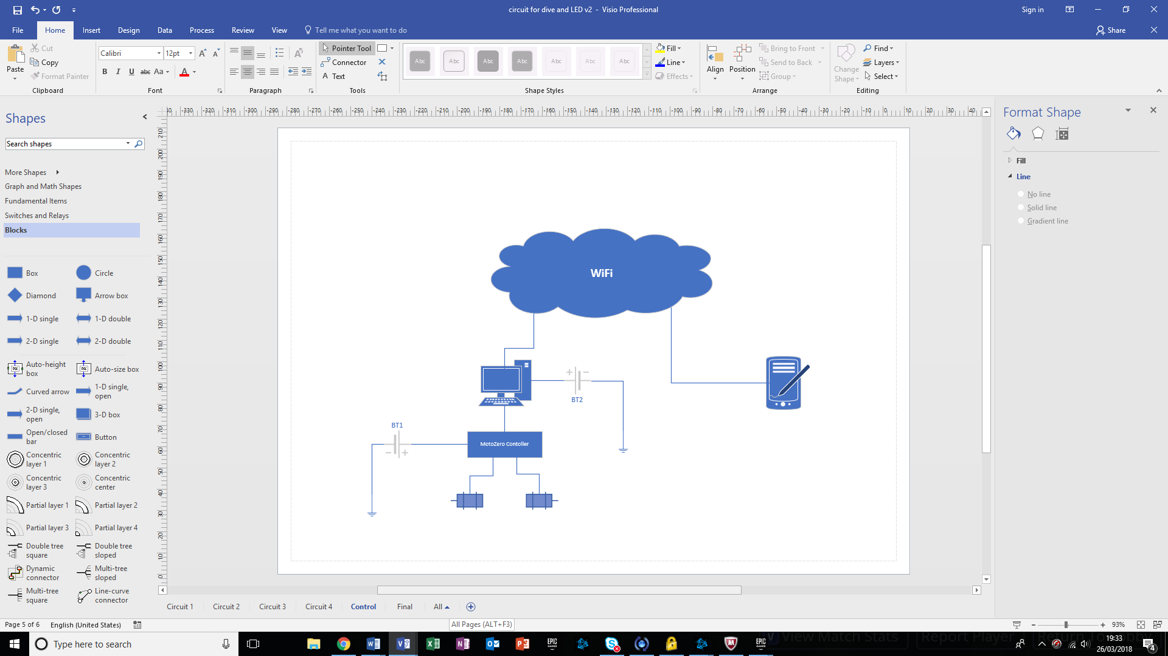

This diagram shows that is happening that you can’t see in a simple way. You send a command on your phone via WIFI this then gets received by pi and put into the motozero which tells the engine what to do and draws the power.

## Programming the Pi

### Program 1

#### Purpose:

This was a program to set the GPIO pin to be off while it was connected to an LED.

#### Code:

import RPi.GPIO as GPIO

# general system information banner

print "PI Type: ",GPIO.RPI_INFO['TYPE']

print "Revision: ",GPIO.RPI_INFO['P1_REVISION']

print "Processor: ",GPIO.RPI_INFO['PROCESSOR']

print "RAM: ",GPIO.RPI_INFO['RAM']

print "Manufacturer: ",GPIO.RPI_INFO['MANUFACTURER']

print "GPIO Version: ",GPIO.VERSION

print

GPIO.setwarnings(False)

GPIO.setmode(GPIO.BOARD)

GPIO.setup(8, GPIO.OUT, initial=GPIO.LOW)

GPIO.output(8, GPIO.HIGH)

### Program 2

#### Purpose:

This program was to use the time library and turn a LED on and off continuously using an infinite loop and the random function to set the interval.

#### Code:

import RPi.GPIO as GPIO

import time

import random

# general system information banner

print "PI Type: ",GPIO.RPI_INFO['TYPE']

print "Revision: ",GPIO.RPI_INFO['P1_REVISION']

print "Processor: ",GPIO.RPI_INFO['PROCESSOR']

print "RAM: ",GPIO.RPI_INFO['RAM']

print "Manufacturer: ",GPIO.RPI_INFO['MANUFACTURER']

print "GPIO Version: ",GPIO.VERSION

print

# initialise GPIO

GPIO.setwarnings(False)

GPIO.setmode(GPIO.BOARD)

GPIO.setup(8, GPIO.OUT, initial=GPIO.LOW)

GPIO.output(8, GPIO.HIGH)

while True:

interval = random.random() * 2

print "sleep interval set for ", interval, "s"

GPIO.output(8, GPIO.HIGH)

time.sleep(interval)

GPIO.output(8, GPIO.LOW)

time.sleep(interval)

### Program 3

#### Purpose:

The purpose of this program is to turn the LED on and off remotely. This was to make sure that I could contact it wirelessly from my phone. It also waits for a command and then switches the LED on for a random amount of time.

#### Code:

import RPi.GPIO as GPIO

import time

import random

import socket

# general system information banner

print "PI Type: ",GPIO.RPI_INFO['TYPE']

print "Revision: ",GPIO.RPI_INFO['P1_REVISION']

print "Processor: ",GPIO.RPI_INFO['PROCESSOR']

print "RAM: ",GPIO.RPI_INFO['RAM']

print "Manufacturer: ",GPIO.RPI_INFO['MANUFACTURER']

print "GPIO Version: ",GPIO.VERSION

print

# initialise GPIO

GPIO.setwarnings(False)

GPIO.setmode(GPIO.BOARD)

GPIO.setup(8, GPIO.OUT, initial=GPIO.LOW)

GPIO.output(8, GPIO.HIGH)

# Open socket for connection to the phone

UDP_IP = "192.168.0.72"

UDP_PORT = 5050

sock = socket.socket(socket.AF_INET,socket.SOCK_DGRAM)

sock.bind((UDP_IP, UDP_PORT))

# infinite loop to handle commands

while True:  
 data, addr = sock.recvfrom(1024)  
 raw=data

interval = random.random() * 2

GPIO.output(8, GPIO.HIGH)

time.sleep(interval)

print "sleep interval set for ", interval, "s"

GPIO.output(8, GPIO.LOW)

time.sleep(interval)

### Program 4

#### Purpose:

The purpose of this code was to receive data from the control application running on the phone (Rootsaid corporation, 2018) and tells you what you have pressed. For example, if you pressed forward it would print “Robot move forward” as it moved forward. However, it won’t actually move!

#### Code:

import RPi.GPIO as GPIO

import time

import random

import socket

# general system information banner

print "PI Type: ",GPIO.RPI_INFO['TYPE']

print "Revision: ",GPIO.RPI_INFO['P1_REVISION']

print "Processor: ",GPIO.RPI_INFO['PROCESSOR']

print "RAM: ",GPIO.RPI_INFO['RAM']

print "Manufacturer: ",GPIO.RPI_INFO['MANUFACTURER']

print "GPIO Version: ",GPIO.VERSION

print

# initialise GPIO

GPIO.setwarnings(False)

GPIO.setmode(GPIO.BOARD)

GPIO.setup(8, GPIO.OUT, initial=GPIO.LOW)

GPIO.output(8, GPIO.HIGH)

# Open socket for connection to the phone

UDP_IP = "192.168.0.72"

UDP_PORT = 5050

sock = socket.socket(socket.AF_INET,socket.SOCK_DGRAM)

sock.bind((UDP_IP, UDP_PORT))

while True:

data, addr = sock.recvfrom(1024)

# receiving data

raw=data

if raw=="forward":

GPIO.output(8,True)

print "Robot Move Forward"

elif raw=="stop":

GPIO.output(8,False)

print "Robot Stop"

elif raw=="backward":

GPIO.output(8,False)

print "Robot Move Backward"

elif raw=="left":

GPIO.output(8,False)

print "Robot Move Left"

elif raw=="right":

GPIO.output(8,True)

print "Robot Move Right"

else:

print "STOP"

GPIO.output(8,False)

### Program 5

Figure 18: Rootsaid command application

#### Purpose :

This allows me to now move the robot wirelessly by pressing a button. This has also extended it to 2 motors to GPIO pin 8, which would be connected to motor 1, and GPIO pin 10, which would be connected motor 2.

#### Code:

import RPi.GPIO as GPIO

import time

import random

import socket

# general system information banner

print "PI Type: ",GPIO.RPI_INFO['TYPE']

print "Revision: ",GPIO.RPI_INFO['P1_REVISION']

print "Processor: ",GPIO.RPI_INFO['PROCESSOR']

print "RAM: ",GPIO.RPI_INFO['RAM']

print "Manufacturer: ",GPIO.RPI_INFO['MANUFACTURER']

print "GPIO Version: ",GPIO.VERSION

print

# initialise GPIO

GPIO.setwarnings(False)

GPIO.setmode(GPIO.BOARD)

GPIO.setup(8, GPIO.OUT, initial=GPIO.LOW)

GPIO.output(8, GPIO.HIGH)

while True:

data, addr = sock.recvfrom(1024)

raw=data

if raw=="forward":

GPIO.output(8,True)

GPIO.output(10,True)

print "Robot Move Forward"

elif raw=="stop":

GPIO.output(8,False)

GPIO.output(10,False)

print "Robot Stop"

elif raw=="backward":

GPIO.output(8,False)

GPIO.output(10,True)

print "Robot Move Backward"

elif raw=="left":

GPIO.output(8,False)

GPIO.output(10,True)

print "Robot Move Left"

elif raw=="right":

GPIO.output(8,True)

GPIO.output(10,False)

print "Robot Move Right"

else:

print "STOP"

GPIO.output(8,False)

GPIO.output(10,False)

## My survey questions

### What is the most exciting robot to watch in robot wars?

1. Flipper
2. Spinner
3. Flails

### What can sustain the most damage?

1. Flipper
2. Spinner
3. Flails

### What can deal the most damage?

1. Flipper
2. Spinner
3. Flails

### What is the most agile robot?

1. Flipper
2. Spinner
3. Flails

### What robot is easiest to drive?

1. Flipper
2. Spinner
3. Flails

### What robot is hardest to deal damage to?

1. Flipper
2. Spinner
3. Flails



## Survey responses

## Interview

### What is the most exciting thing about flippers to watch in robot wars?

I love the way that many of them have the strength to flip the other robot right into the air. Usually the most damage is inflicted as the robot lands again and breaks itself with its own bulk!

### Why can flippers sustain so much damage?

When the flipper is down, it is less vulnerable than robots that have their weapons exposed.  Spinners often find it difficult to damage them as the sides of a flipper can be sloped. This slope means that the spinner can only inflict a glancing blow.

### Why can spinners deal a lot damage?

Spinners can store up a great deal of energy. They can arm themselves by efficiently accelerating their heavy blades over a few seconds. If a spinner is provided with an edge or a non oblique surface huge damage can be caused as the spinner can release the massive stored up kinetic energy in a fraction of a second.

Force = mass  x acceleration;  if it’s heavy blade is brought to a stop in milliseconds then the forces involved can be massive. The downside is that the bearings and supports and drive of the spinner need to withstand these repeated shock loads without failure.

### Why are flippers the most agile robot?

Horizontal spinners steering can be affected by spinning up and deployment. Unlike spinners, there are no gyroscopic forces present. A flipper can take a very short time to re-arm.  The flipper can also double as a righting device should it be turned over.

### Why are flippers easiest to drive?

Simply, their horizontal direction is not affected by the use of their weapon.

### Why are spinners hardest to deal damage to?

Because of the risk of being damaged yourself!  A failed flipper attempt on a spinner can mean that the flipper mechanism becomes venerable to attack.  A direct spinner blow on a flipper mechanism will usually result in catastrophic failure. Flippers must be sure that they have their blade lodged under a solid surface on the opponent before deployment.



## Methodology table

## Bibliography

BBC, 2017. *Battle Rules.* [Online]   
Available at: http://www.bbc.co.uk/programmes/articles/20zGntPHlh74VX2MtHXz6xY/the-battle-rules  
[Accessed 13 December 2017].

BBC, 2018. *The battle rules.* [Online]   
Available at: http://www.bbc.co.uk/programmes/articles/20zGntPHlh74VX2MtHXz6xY/the-battle-rules

bots, b., 2018. *battle bots.* [Online]   
Available at: http://www.battlebotsupdate.com/robot-wars-uk-s8-e6/

components, R., 2018. *DC geared motors.* [Online]   
Available at: https://uk.rs-online.com/web/c/automation-control-gear/electric-motors-motor-controllers-peripherals/dc-geared-motors/?searchTerm=motors&pn=1  
[Accessed 23 3 2018].

components, R., 2018. *RS Pro Brushless DC Motor.* [Online]   
Available at: https://uk.rs-online.com/web/p/dc-motors/5366030/  
[Accessed 23 3 2018].

Devices, Q., 2018. *Brushed vs Brushless.* [Online]   
Available at: http://www.quantumdev.com/brushless-motors-vs-brush-motors-whats-the-difference/  
[Accessed 23 3 2018].

Ellis, 2018. *Pulsar (Robot Wars) - Buil Update for BBC - 15/2/2016.* [Online]   
Available at: https://www.youtube.com/watch?v=rHEqudaxDy8

Fadom, 2018. *Carbide.* [Online]   
Available at: http://robotwars.wikia.com/wiki/Carbide?action=edit&section=1

Fandom, 2018. *tiberus fandom.* [Online]   
Available at: http://robotwars.wikia.com/wiki/Tiberius

foundation, R. p., 2018. *GPio usage.* [Online]   
Available at: https://www.raspberrypi.org/documentation/usage/gpio-plus-and-raspi2/README.md  
[Accessed 23 3 2018].

Joe, 2018. *Joe.* [Online]   
Available at: https://www.joe.ie/movies-tv/joe-meets-angela-scanlon-the-new-presenter-of-robot-wars-554187

NJGW, 2018. *Robot wars 2016 top 10 Battles.* [Online]   
Available at: https://www.youtube.com/watch?v=8kVn1aGVxGA

Robotshop, 2018. *Robot shop.* [Online]   
Available at: https://www.robotshop.com/blog/en/how-do-i-interpret-dc-motor-specifications-3657  
[Accessed 23 3 2018].

Rodger, 2018. *Rodger's hobby centre.* [Online]   
Available at: https://rogershobbycenter.com/lipoguide/  
[Accessed 23 3 2018].

spy, D., 2018. *Digital spy.* [Online]   
Available at: http://www.digitalspy.com/tv/robot-wars/news/a841780/robot-wars-carbide-gabriel-battle-viewers-reactions/

update, B., 2018. *CARBIDE.* [Online]   
Available at: https://www.google.co.uk/search?safe=strict&biw=2133&bih=1082&tbm=isch&sa=1&ei=r7VoWoyJLauHgAaIiIRQ&q=carbide+robot+wars&oq=carbide+r&gs_l=psy-ab.3.0.0l10.1809.5409.0.6607.8.6.1.0.0.0.559.1170.1j2j1j5-1.5.0....0...1c.1.64.psy-ab..2.3.432...0i67k1.0.7AX2Rf

wars, R., 2018. *Apollo.* [Online]   
Available at: http://www.robotwars.tv/competitors/season-10/week-1/apollo/

wars, R., 2018. *Carbide.* [Online]   
Available at: http://www.robotwars.tv/competitors/season-8/week-1/carbide/

wars, r., 2018. *robot wars competitors.* [Online]   
Available at: http://www.robotwars.tv/competitors/season-10/week-1/apollo/

wars, r., 2018. *robot wars competitors.* [Online]   
Available at: http://www.robotwars.tv/competitors/season-10/week-4/nuts-2/

wars, r., 2018. *robotwars competitors.* [Online]   
Available at: http://www.robotwars.tv/competitors/season-10/week-5/thor/

WikiHow, 2018. *How to build a robot.* [Online]   
Available at: https://www.wikihow.com/Build-a-Robot-at-Home

WikiHow, 2018. *How to wirelessly control a robot.* [Online]   
Available at: https://www.wikihow.com/Build-a-Remote-Controlled-Robot

## Evaluation

## My HPQ story

Overall, I have found this project very enjoyable and I have benefited hugely from doing it. I think that I have developed a lot of skills but the one that has developed the most is my planning of longer projects because that was one of my weakest points but now I have improved it considerably. Before I started this project, I couldn’t solder or fix a circuit board but now I can and I am very confident with this new skill. This is good for me as it allows me to continue to learn and progress to become an engineer. I am sure that if I did this again my planning would be a lot better from the start and I would have plenty of time to finish and maybe push myself a bit more in those first couple of weeks. If I did this then I would be able to spend more time looking over my research and still get it done on time at the same high standard. I feel that my research has become quite detailed and of a good quality. This research has helped me to create to remote control robot that I have that can be driven around the house with having to be weighed down by cables. However, I would not choose another subject because I think that I have only covered a tiny bit of a huge fascinating subject. I also think that it would be really fun to have multiple homemade robots just wandering around.

## How did I manage my time?

During my project I found that time management was key to completing everything in time. First of all, I made my time plan. This consisted of several months split into 4 weeks. However, I found that the tasks I had set had become irrelevant as the project evolved. This meant that I had to revise my timetable and redo it with relevant tasks. However, later on in the project I began to stray from the time plan and just ‘wing it’ this might have been a mistake but the project kind of directed itself and so I just did whatever was needed to do to keep it moving. As I neared the end of my project I realised that I had to catch up and refine all of my research and how it was all presented but that worked fine. When I was using this plan I found it very helpful as it helped cut out the tangents however, I struggled to keep checking it and eventually just gave up and let the project lead its self if I could do this again I would spend a lot of time getting the plan right as it can be such a useful thing to help motivate you and tell you when you are behind which is very hard to work out on long projects like this. I also did another plan to help keep track of my time that is my reflective diary. This is where every time I make a change to my project I write it down in my diary this is very useful as it helps me remember what I have done when I am collecting everything together. However, I failed to fill it in every so often so it became a job to catch up and bring it back up to date one time I struggled a lot with this but all the others were just 1-2 days. Overall, I found this quite helpful when I remembered to do it but if also held me back when I didn’t and I think that I needed to start my project by doing more planning and make sure I stick to that plan.

## How thorough is my research?

I think that my research was quite thorough and of a high standard. However, I think that my research should have covered a wider range of topics as I had trouble finding a large quantity that was already made. Having said this I think that in my project I need more secondary research this is because the only secondary research that I did was read two books published by robot wars. I also struggled with reliability and had to use wikihow instead of more reliable source such as the official robot wars website. If I could do this again I would make a list of things I wanted from my research so I can make sure the websites give me what I want. I would also give myself more time to cross check the information between websites to prove their reliability. If I had had time to do this I reckon I could’ve had a lot more research. I am also struggling to sort my research in to any rhyme or reason because everything is saying something different. If I had had those reliable sources I would have been able to look at my source from a different angle.

## What skills have I developed through doing the project?

I have developed a lot of skills through HPQ for example my problem solving has greatly improved. I have faced a lot of problems going through my project but I always managed to find a solution. One of my biggest problems was that the TV show that this was based on got cancelled this meant that I couldn’t build a weaponised robot so I had to make prototypes and replace the weapon with a light. Another skill I have developed is my determination. Before I did this project, I got distracted very easily and could only work for 30 minutes max before I needed a long break and couldn’t do that for long. However, I found that as I progressed through this project I was being forced to work for hours on end because there just wasn’t enough time to get through all the things I had planned. I also improved on my soldering skills as before this project I could barely solder but now I soldered a whole circuit together and without that skill I would not have been able to complete my project. Finally, I improved my writing skills most of all though because I found that now in one sitting I could comfortably write one thousand words if I could get the structure right. This is such an important skill as it not only applies to this project but it will continue to be relevant all through my life.

## Are my final outcomes what I originally intended or have the changed?

Throughout my project I found that my outcomes kept changing. It started off as me building a weaponised robot and entering it into robot wars. I was planning to order the parts early on but failed to find enough suitable components within my budget. I also didn’t have the tools to weld the metal or shape it so I decided to scale it down to a design. However, once I had settled for a design I had a massive break through on my prototype when I switched from Lego to Meccano and started to get it wireless this meant that I had a change of heart and decided to build a non-weaponised prototype of my model. I had also changed my title as it started off on a completely different subject talking about how in computer games it can unite the world and give them a common enemy to fight against. However, it was really hard to get any research on this as it is completely fictional and was based on what I heard a comedian say.

## What difficulties did I face and how did I overcome them?

I faced a lot of difficulties but most of them were minor like not having a part so having to order it online. However, I did have a big one, this was when the TV show this project is based on closed down and I had to give up on the idea of entering my robot into it. I also became quite far behind as my supervisor was off and it was hard to push myself forward on the information we had been given. This then meant I had to catch up to the pace and this set my plan way off meaning that it was a lot harder to use as I was 2 weeks behind.

## How could my project be built on?

I think that it could be very interesting if I looked into mass control or developing AI as these are both huge areas with boundaries that are getting crossed every day. The mass control could be having multiple robots work together to clean a room and after I got them to clean a room I could make it so that they could clean a house. If I didn’t do that I could do it so if you set time the robot could clean your entire house put itself back on charge and then do this again the next day and so on until you tell it to stop. Another fascinating topic could be voice control I know we already have this in our everyday lives but I was thinking something like telling your pen what to write or telling a table to move forward 3cm. If we could do this is would entirely change our lives if you can’t find something you tell it to beep and then you can get to that noise and find it. This method could save hours and also would be very convenient for the users. To make sure it would work you could go through the alphabet in different moods or say the alphabet in different tones and we could assign it to unlocking phone like we do our fingerprint now days.

## What would I do differently if I were doing the project again?

If I could do this project again I would spend more time planning and use my interest a lot more to drive me through this project to the end result. If I did I think I would have a lot better of a design and would have made it wireless a lot faster. I would also make it so that my time plan had more detail and a stricter guidance so I do more of the work earlier. I would have also asked more questions because I felt at the start I was flailing to try and get the information I needed and that it would have saved a lot of time if I had asked it up front. I would also make sure that I put my research into the bibliography as soon as I found it and not procrastinated doing it for so long.

## Conclusion

In conclusion I think that it went very well and I am very proud of what I have done and for completing it. There are a few things I would like to improve and one of these was the quantity of my research. Next time I would have looked at more past projects so that I can get an idea on the mark scheme and check to make sure I have covered it.

## My SWOT analysis

**W**eaknesses

I think that there were a few mistakes in my project one of them is that the prototypes aren’t weaponised and that I can no longer enter it into robot wars.

**S**trengths

I am really proud of my final prototype. I have planned for it and it works so well. I also think that I managed to bring my research together really well. I have also been able to make connections to IT

**T**hreats

The biggest threats were unplanned one such as robot wars being cancelled and my supervisor’s absence.

**O**pportunities

This project will give me lots of opportunities as I want to be an engineer and building a robot is quite technical and involves many different engineering disciplines

## How to win Robot Wars.

My project is about how to win robot wars and building a robot. Over the course of this project I have changed my title and researched it. I have also added to my project and changed what I was researching. Not only that but I have developed lots of skills. For example, I am a lot better at soldering than I was before but also planning and solving problems. This project has made me a lot more confident with doing projects, which will be very useful as I progress through the school as I will be ready for the project I get given.

## Primary research

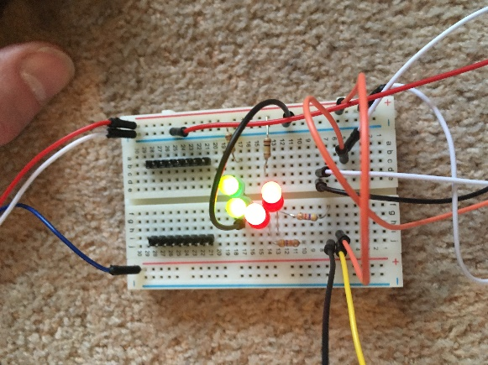My primary research was made up of multiple stages: The first one was sending out a questionnaire to the robot wars community on reddit where I received some good responses and some bad; it the involved an interview that I sent to my uncle because he is an engineer, this helped me a lot with my understanding of the topic and different weaknesses and strengths; I also built some models to help my understandings and to see if some of my ideas where possible; I also had to use a lot of circuitry to make the motors work and try using the transistors this meant that I learnt a lot about electronic circuits and how to use breadboards with my raspberry pi; and finally I researched the two previous winners Apollo and Carbide however I realised that this information wasn’t relevant enough as there was no information about their dimensions or what they were made of so I stopped part way through.

## Secondary research

I have not done very much secondary research however the bit I have done has been very valuable and I keep using it for more information. For my secondary research I read two books one was called Robot wars the official handbook which detailed robots names their weapons, weight, defence, top speed, drive systems, power, battery, biggest weakness, their strengths and the amount of team members. This is very useful as one it shows me the flaws in each design so I can use this to not include them in my robot design. The second book is called ‘Robot wars Build your own robot’ This is useful as it gave templates for some robots that I nearly built, it also has the history of robot wars, the types of robots, their application, the design and development and design of the house robots, the anatomy of each house robot (Robot wars limited, 2018), how to build a robot safely, how to win robot wars, the rules an previous winners (Robot wars limited, 2018). These are useful to me as I need to make my robot be in the rules I need to be able to build it but I also need to know what options I have for weapons.

## How to win robot wars?

To win robot wars you need many things. A few of which are agility good driving, a strong weapon and very strong armour. If you are missing any of these things you will have to work very hard and excel in all the others to have a chance. On top of this you will also need to get a robot working (which I have managed to do in both of my prototypes), no loose connections (which is very easy to accidentally do) and no dry joints. Otherwise your robot will break mid fight and therefore costing you the match. However, in my opinion the hardest thing to do is to make your robot completely wireless as this forces the driver to rely on their code. This makes it riskier as the pi could get damaged and the code stop running therefore not allowing you drive or use your weapon. This means you will lose as the immobilisation count down will start and you have 10 seconds to try and move (BBC, The battle rules, 2018).

## Weapons

There are 4 main weapons I am going to write about in this section, they are: Flippers, Spinners, Flails and Axe/Hammer. Each of these have their advantages and disadvantages and I am going to run through them.

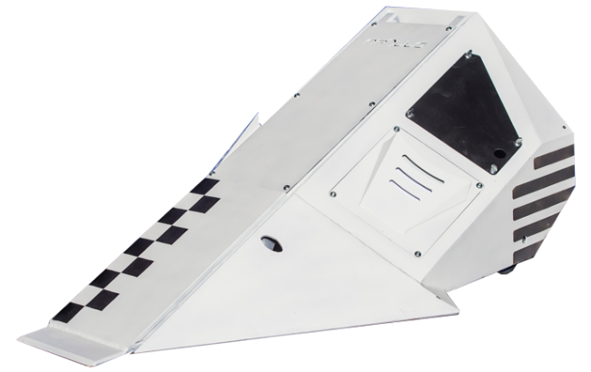Flippers are very good at finishing match if the other robot doesn’t have a self-righting mechanism. However, even if they do have one getting flipped gives the robot quite a battering and earns you points with the judges. Not only that but even if your flipper stops working as long as it is stuck down you can use your drive to wedge and push people into the pit and hence win the battle. The disadvantages of the flipper are that you have to be very conservative with your CO2 otherwise you are left open to a lot of attacks without that much defence and even though flippers stereotypically have a lot of armour eventually it will just give in and the robots interior will be battered and very hard to repair. Unfortunately, this is not the only weakness as flippers will struggle to end a battle if the robot has a functional self-righting mechanism and this often causes the battle to go to the judges which isn’t always as exciting as a battle where a robot is eventually outplayed and beaten, this is relevant as one of the judge’s criteria is how exciting the robot was in the fight. Another advantage of the flipper is that it is very heavily armoured, this means that it can take a lot of hits and still be aggressive which is very useful as robot aggression and taking hits are both on the judge’s criteria.

Figure 19 Apollo: flipper robot

Spinners are very good at dealing damage incredibly fast a great example of this is carbide where he sped up his spinner and takes most opponents against him out in one shot. This is great as it is very exciting to watch and can deal immense damage which is also on the judge’s criteria (Robot wars limited, 2018)and immobilise opponents which will 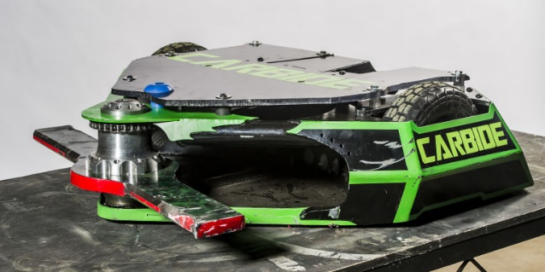end the battle. Not only

Figure 20 Carbide: spinner robot

that but they are very hard to deal damage to because if you get too close they will possibly finish you. A big disadvantage of the spinner is durability. This is a problem because every big hit they do they take some of the shock as well and risk damaging the internal systems and possibly immobilization. Another disadvantage is if their bar gets up to speed it becomes a lot harder to drive. Good driving is on the judge’s criteria. The lack of control can cause them to miss their target and, in one case, even cause damage to the arena. This forced the match to end (bots, 2018). Not only this but the bars spinners’ use are very heavy and will use a lot of the weight limit. This combined with the motor and battery will take up most of the weight limit and make it so that the spinner doesn’t have much armour protecting it. This means that if it does get hit it is much more likely to get finished than a Flipper.

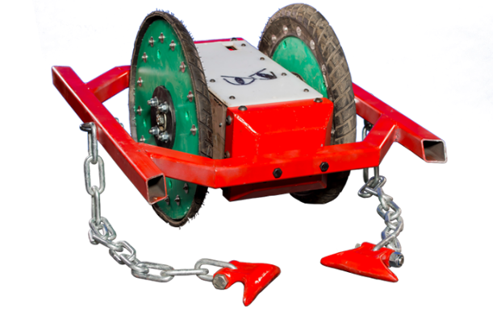Now I am going to talk you through the advantages and disadvantages of Flails. Flails are a very interesting robot as there has only ever been two flails entered robot wars ever in its history and they were nuts and nuts 2 and in these two entries have only ever won one fight and this was when they beat two time champion carbide by getting a direct hit on carbides drive belt with one of its flails and hence immobilizing carbides weapon allowing nuts to become more aggressive and eventually win the fight thanks to the judges giving it to them. The advantages of Flails are that they can fight at a longer range than every other robot they will face this means that they are very hard to hit and if you do want to hit them you will have to take a big hit from one of the flails. The disadvantages are that all the weight has to be put into the flails for them to be effective and therefore literally has no armour leaving it very open to attack if the enemy robot can get within range to hit them it is very often the end of the fight. This is why Flails are the least used robot in robot wars.

Figure 21 Nuts 2: flail robot

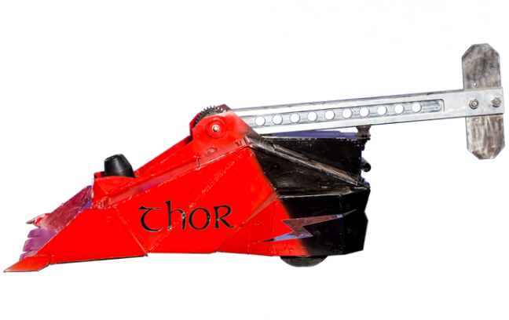Finally, I am going to talk you through the advantages of axe/hammer robots. The main advantage of axe/hammer robots is that they attack one of the two common weak points of most designs and that is the top side of it because they strike on top and try to damage the interior systems. They are also very effective as they can have a lot of armour because the axe system is quite light therefore more weight for the armour to fill. Most successful axe/hammer robots use a blunt axe/hammer in an attempt to break the interior hardware with concussive shock this is very effective however only two robots have taken this to its full potential. They are Shunt and Thor, Shunt is a house robot with an axe on the top and a flipper on the front. Thor however was an actual competitor who has entered multiple times. The disadvantages of them is that if it isn’t used well it is quite hard to finish anyone or be overly aggressive, another big advantage is that if the weapon stops working (which is quite often) it has very powerful engines which means it can push around the enemy robot and possibly push it in to pit.

Figure 22 Thor: hammer/axe robot

## Batteries

There are two main types of batteries that I was looking at they were LiPo batteries and NiMH batteries in the end I opted for LiPo batteries.

The advantages of LiPo are that they are significantly lighter than other batteries and can also be made into almost any shape or size this means that they can easily fit into your robot design and won’t take up much of the weight limit. They also have higher capacities this allows them to hold more power and higher discharge rates, this means that they can pack a ‘punch’ and push the other robot around if the weapon fails. The disadvantages of the LiPo are that if you join the positive and negative side of it for the first few minutes it smokes then catches fire and then the battery has melted and if this where to happen in the robot it could quite easily cost you the fight and even if you get far enough the robot wars title not only that but it also means you are vulnerable to attack on the batteries. They also have a shorter life span lasting only 150 to 250 cycles (this is the amount of full charges and discharges but if it is down to 60 then charged to 80% that wouldn’t count as a cycle) This means that if you are going to use your robot for any length of time you would have to use multiple batteries or recharge them. They can catch light if the battery gets punctured, and also it needs very special care for storing charging and discharging this means it needs lots of attention when repairing your robot and will take up the little time you have between fights and possibly make you forfeit.

The advantages of NiMH batteries are that they have a lot longer of a lifespan often lasting up to 1000 cycles, they also a lot safer as they aren’t as sensitive and don’t pose a fire risk this means that if they are hit by a robot they are safer and less likely to lose you the fight. It is also very easy to recharge the batteries as simple chargers and routines are required this means that it is less money to invest on charging them and more money to invest in the actual robot. The disadvantages of the NiMH batteries are that they are much heavier and limited on size this means that they take up a lot more of the weight in the weight limit but also the robot will have to adapt to fit them in. They have a lower capacity and are overall less efficient this means that the weight they are using isn’t as well used as they LiPo batteries. They also have bad discharge rates and lack a ‘punch’ this means that they won’t have the driving power and will mean you can get pushed around (Rodger, 2018).

## Conclusion

Overall, I think that building a robot is a great experience and very exciting as you never know what can happen for example ‘If a spinner is provided with an edge or a non-oblique surface huge damage can be caused as the spinner can release the massive stored up kinetic energy in a fraction of a second.’ As mentioned in the interview with Gordon Stimpson. Not everyone has to do it but it has a great learning curve and is fascinating. It can also get you into coding, electronics and mechanical engineering. The more you do it the better your robot becomes for example I realised how to increase the speed of turning did it and then went on to improve something else. You can always improve on what you have done and when you reach the top you can push boundaries and re make life as we know it.

It is predicted that household humanoid robot will be the norm in 2050 (Futurism, 2018) so it is important to try and bring the date sooner!